Name : K.AravindRoyal

Trainer Name:- Harshee pithoda

Course Name:-python for machine learning

Date :-30/05/22

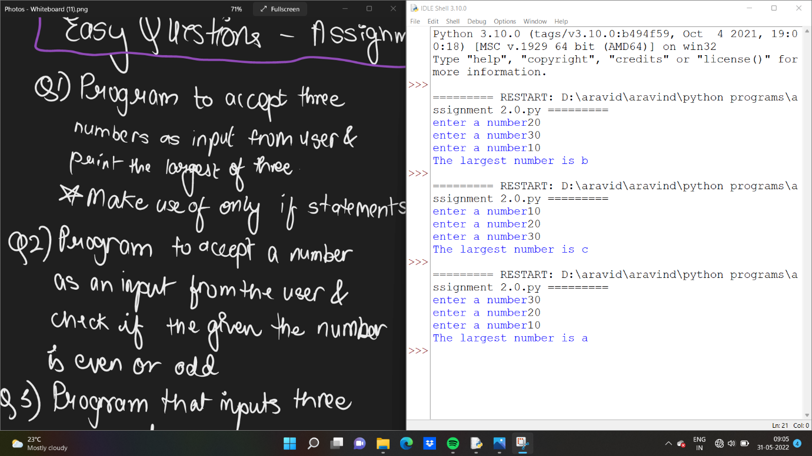

a=int(input('enter a number'))

b=int(input('enter a number'))

c=int(input('enter a number'))

if a>b and a>c:

print('The largest number is a')

if b>c and b>a:

print('The largest number is b')

if c>a and c>b:

print('The largest number is c')

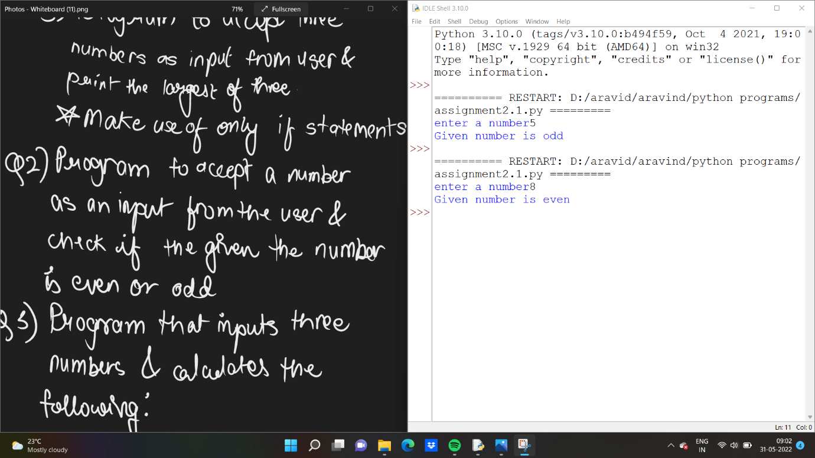

a=int(input('enter a number'))

b=a%2

if b==0:

print('Given number is even')

else:

print('Given number is odd')

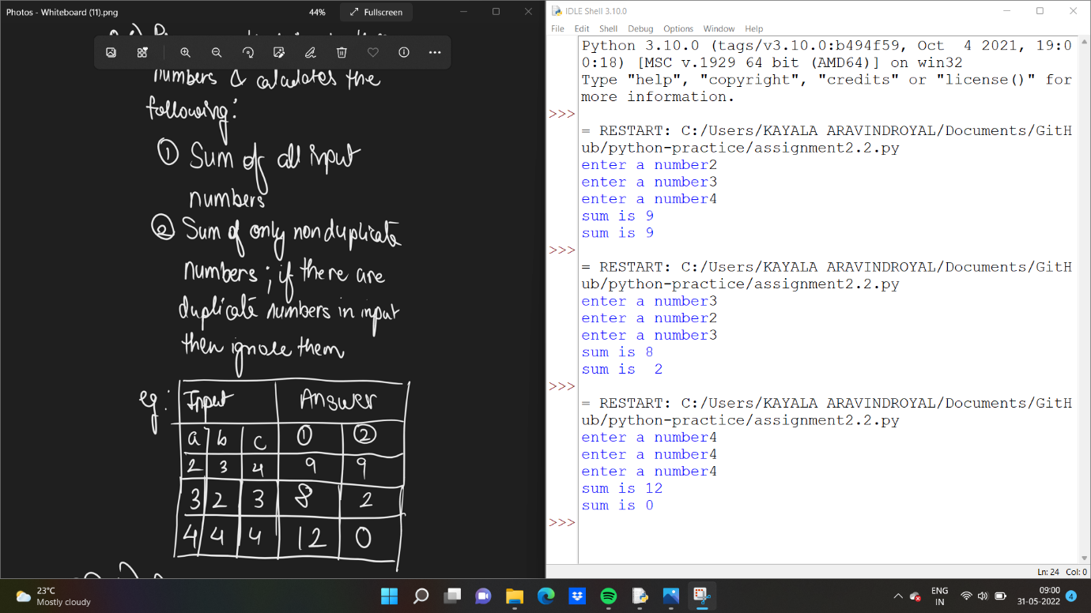

a=int(input('enter a number'))

b=int(input('enter a number'))

c=int(input('enter a number'))

print('sum is',a+b+c)

if a==b and a==c:

print('sum is 0')

elif b==a and b==c:

print('sum is 0')

elif c==a and c==b:

print('sum is 0')

elif a==b:

print ('sum is ',c)

elif a==c:

print('sum is ',b)

elif b==c:

print('sum is ',a)

else :

print('sum is',a+b+c)

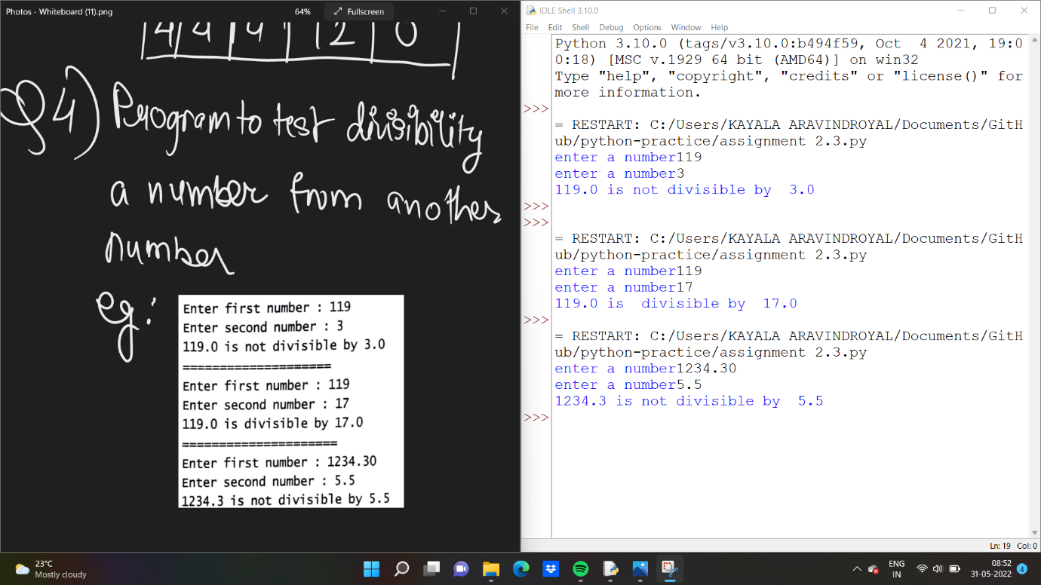

a=float(input('enter a number'))

b=float(input('enter a number'))

if a%b==0:

print(a,'is divisible by ',b)

else:

print(a,'is not divisible by ',b)